‘Test your nerves’ game

Follow the instructions below to make your own electronic game to
‘Test your nerves’ based on your knowledge of simple circuits.

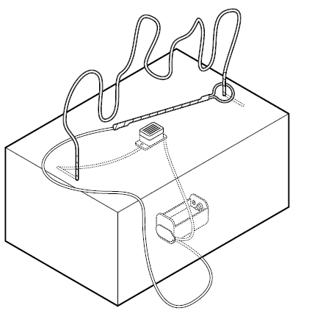
The idea of the game is to get the hand loop across the large bendy wire without touching it. Hence the title ‘Test your nerves’. If you do touch the bendy wire the buzzer should sound.


